Project One - Business Requirements

Ketlheen Silva

Southern New Hampshire University

CS-255 System Analysis and Design

Aline Yurik

October 2, 2026

CS 255 Business Requirements Document Template

Complete this template by replacing the bracketed text with the relevant information.

This template lays out all the different sections that you need to complete for Project One. Each section has guiding questions to prompt your thinking. These questions are meant to guide your initial responses to each area. You are encouraged to go beyond these questions using what you have learned in your readings. You will need to continually reference the interview transcript as you work to make sure that you are addressing your client’s needs. There is no required length for the final document. Instead, the goal is to complete each section based on your client’s needs.

Tip: You should respond in a bulleted list for each section. This will make your thoughts easier to reference when you move into the design phase for Project Two. One starter bullet has been provided for you in each section, but you will need to add more.

System Components and Design

Purpose

What is the purpose of this project? Who is the client and what do they want their system to be able to do?

- The purpose of this project is to design a system for DriverPass that addresses a problem the company sees in driver education. DriverPass has noticed that many people fail their DMV driving tests because they are not properly prepared. To address this problem, DriverPass wants to provide customers with better training through online classes, practice tests, in-person instruction, and on-the-road training. The new system will bring these services together and allow DriverPass to manage its customers, training, appointments, and other business needs in one place.

System Background

What does DriverPass want the system to do? What is the problem they want to fix? What are the different components needed for this system?

- DriverPass needs a web-based system, preferably hosted through the cloud, that allows the company to manage its training services and customer information in one place. The system will have several components, including user account management, customer registration, appointment scheduling, training packages, online classes and practice tests, driver notes, activity tracking and reports, and communication with customers. The system will also connect with the DMV to receive updates to rules, policies, and sample questions.
- The system will support different users, including the owner, IT officer, secretary, customers, and drivers. Each user will have access based on their role. Customers will be able to schedule, modify, and cancel appointments, while the secretary can schedule appointments for customers who call or visit the office. The IT officer will have greater account access to maintain the system, reset accounts, and block access when necessary. The system will also track which customer is assigned to a specific driver, vehicle, date, and time. DriverPass employees will be able to access information from different computers and mobile devices, while downloaded information can be viewed or worked with offline without modifying the live system data.

Objectives and Goals

What should this system be able to do when it is completed? What measurable tasks need to be included in the system design to achieve this?

- Allow customers or the secretary to register customers and collect required information, including name, address, phone number, state, payment information, and pickup/drop-off location.
- Allow customers to select and purchase one of the three available DriverPass training packages.
- Allow customers to schedule, modify, and cancel two-hour driving appointments online.
- Track the customer, driver, vehicle, date, and time associated with each driving appointment.
- Allow DriverPass employees to disable a training package so new customers can no longer select it.
- Allow customers to automatically reset forgotten passwords and allow authorized IT personnel to manage employee accounts and access.
- Track who creates, modifies, or cancels reservations and generate activity reports showing those actions.
- Display each student's practice-test progress, including the test name, time taken, score, and status of not taken, in progress, failed, or passed.
- Maintain driver notes for each lesson, including lesson time, start time, end time, and driver comments.
- Receive notifications when the DMV updates rules, policies, or sample questions so DriverPass can keep its training materials current.
- Provide a way for customers to contact DriverPass and for DriverPass employees to contact students.
- Allow authorized users to access the system from computers and mobile devices and download reports or information for offline use.
- Maintain role-based access so different users have the appropriate permissions based on their responsibilities.
- Maintain student profiles/information and training progress.

Requirements

Nonfunctional Requirements
In this section, you will detail the different nonfunctional requirements for the DriverPass system. You will need to think about the different things that the system needs to function properly.

Performance Requirements
What environments (web-based, application, etc.) does this system need to run in? How fast should the system run? How often should the system be updated?
- The system should be web-based and preferably use the cloud so users can access it from different computers and mobile devices.
- Users should be able to download reports and other information to use offline. However, changes to the system should only be made while online to avoid having duplicate or different information stored in the system.
- The system should receive notifications when the DMV updates its rules, policies, or sample questions so DriverPass can keep its information and training materials up to date.
- The cloud should also help with backups and security so DriverPass can focus more on running the business and have fewer technical problems.

Platform Constraints
What platforms (Windows, Unix, etc.) should the system run on? Does the back end require any tools, such as a database, to support this application?
- The system should run through the web and preferably be hosted in the cloud. Users should be able to access it from computers and mobile devices.
- The system will need a database to store customer information, reservations, training information, driver notes, and other important records.
- The database should also keep track of who created, changed, or canceled reservations so DriverPass can create and print activity reports.
- Users should be able to download reports and some information to work with outside of the system, such as in Excel.

Accuracy and Precision
How will you distinguish between different users? Is the input case-sensitive? When should the system inform the admin of a problem?
- The system should have different users, including the Owner, IT Officer, Secretary, Customer, and Driver. Each user should only have access to the information and functions needed for their role.
- Each user should have their own account so the system can identify who is using it and who makes changes.
- The IT Officer should have full access to employee accounts and be able to reset or block an account when needed.
- The system should keep track of who creates, changes, or cancels a reservation so DriverPass can see who was responsible for each action.
- The system should accurately track the customer, driver, vehicle, date, and time for each driving appointment.

Adaptability
Can you make changes to the user (add/remove/modify) without changing code? How will the system adapt to platform updates? What type of access does the IT admin need?
- The IT Officer should be able to manage user accounts, reset accounts, and block access without needing to change the system code.
- Different users should be given access based on their role in DriverPass.
- DriverPass should be able to disable a training package when they no longer want new customers to select it.
- Adding or removing complete training packages would require a developer or systems analyst and could be added as a future feature.

Security
What is required for the user to log in? How can you secure the connection or the data exchange between the client and the server? What should happen to the account if there is a “brute force” hacking attempt? What happens if the user forgets their password?
- Users should be required to log in to their own account before accessing the system.
- Each employee should have different access depending on their role.
- The IT Officer should have full access to employee accounts and should be able to reset or block an account when needed.
- Customers should be able to automatically reset their password if they forget it.
- Since the system will preferably use the cloud, backups and security should be handled through the cloud service instead of DriverPass having to manage them directly.

Functional Requirements
Using the information from the scenario, think about the different functions the system needs to provide. Each of your bullets should start with “The system shall . . .” For example, one functional requirement might be, “The system shall validate user credentials when logging in.”
- The system shall allow the customer or secretary to enter and maintain customer information, including name, address, phone number, state, payment information, and pickup and drop-off location.
- The system shall allow customers to select from the three DriverPass training packages.
- The system shall allow DriverPass to disable a training package so new customers can no longer select it.
- The system shall allow customers to make, change, or cancel driving appointments online.
- The system shall allow the secretary to make appointments for customers who call or visit the office.
- The system shall schedule driving lessons in two-hour sessions.
- The system shall keep track of the customer, driver, vehicle, date, and time for each appointment.
- The system shall track who creates, changes, or cancels a reservation.
- The system shall create activity reports that can be viewed and printed.
- The system shall allow customers to automatically reset a forgotten password.
- The system shall provide different access based on the user's role.
- The system shall allow the IT Officer to manage employee accounts and block access when needed.
- The system shall provide online classes and practice tests based on the customer's training package.
- The system shall display the student's practice-test progress, including the test name, time taken, score, and whether the test is not taken, in progress, failed, or passed.
- The system shall allow drivers to add notes for driving lessons, including lesson time, start time, end time, and comments.
- The system shall receive notifications when the DMV updates its rules, policies, or sample questions.
- The system shall provide a way for customers to contact DriverPass and for DriverPass employees to contact students.
- The system shall allow authorized users to access the system from computers and mobile devices.
- The system shall allow reports and other information to be downloaded and used offline, but changes to live system information should only be made while online.

User Interface
What are the needs of the interface? Who are the different users for this interface? What will each user need to be able to do through the interface? How will the user interact with the interface (mobile, browser, etc.)?
- The system should have a web-based interface that users can access from computers and mobile devices.
- The interface should have a form where the customer or secretary can enter student information, such as name, address, phone number, and other required information.
- The student's profile should show online test progress, including the test name, time taken, score, and status.
- The interface should show driver notes, including the lesson time, start time, end time, and driver comments.
- The interface should have a place for the driver's photo and student's photo.
- The interface should also have a page for customers to contact DriverPass and a way for employees to contact students.
- Authorized employees should be able to view and print activity reports.

Assumptions
What things were not specifically addressed in your design above? What assumptions are you making in your design about the users or the technology they have?
- It is assumed that users will have a computer or mobile device with internet access when they need to use the live system.
- It is assumed that users have basic knowledge of how to use a website on a computer or mobile device.
- It is assumed that DriverPass employees will have internet access when they need to add or change information in the system.
- It is assumed that the DMV will provide DriverPass with the updates needed to keep its rules, policies, and practice questions current.
- It is assumed that users will only have access to the information and functions allowed for their role.

Limitations
Any system you build will naturally have limitations. What limitations do you see in your system design? What limitations do you have as far as resources, time, budget, or technology?
- Users will not be able to change live system information while offline. They will only be able to work with information or reports that were already downloaded.
- An internet connection will be needed to make, change, or cancel appointments and to access the most current information.
- DriverPass employees will not be able to add or remove complete training package modules themselves. This would require help from a developer or systems analyst.
- Since the system is web-based and uses the cloud, access to the live system will depend on having an internet connection

Gantt Chart
Please include a screenshot of the GANTT chart that you created with Lucidchart. Be sure to check that it meets the plan described by the characters in the interview.

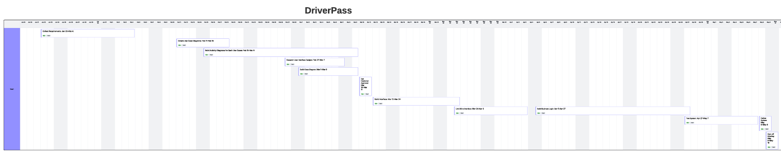
Full chart:

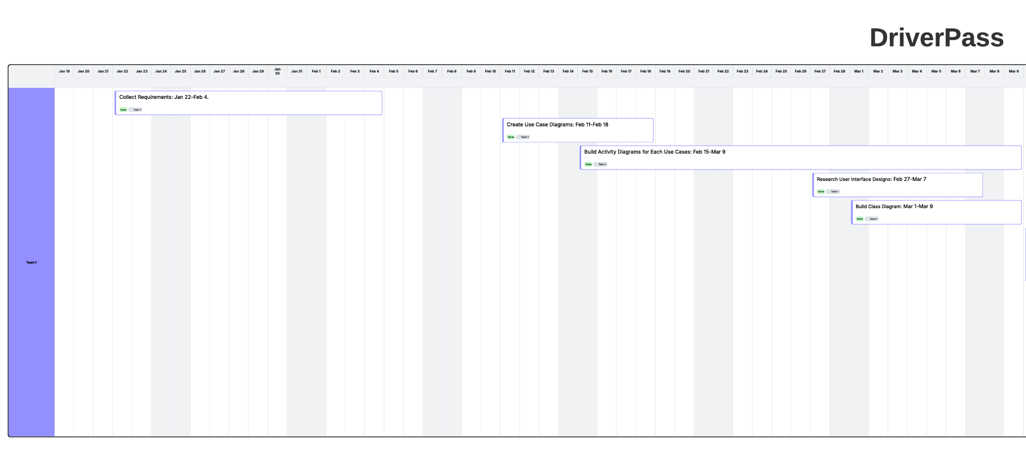
Gantt Chart - Part 1:

Gantt Chart - Part 2:
